Emitter Peaking:

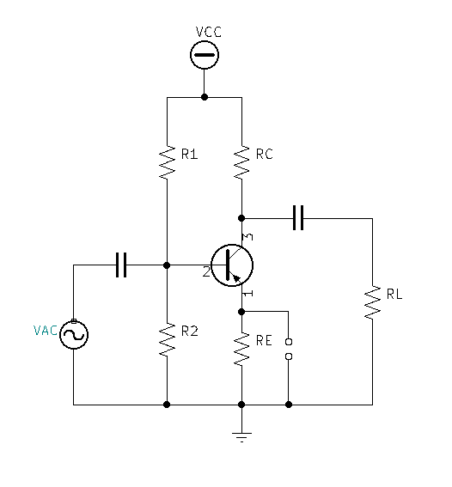

* Calculate and or Measure your existing $fch$.
* Determine your predicted $new fch$ will be if emitter peaking is added:
  + If $-3dB$ is elevated to $0dB$, then the existing $-6dB$ will become the new $-3dB$
  + Find the $-6dB$ frequency $f$ at the existing $fch$
$-6dB=20log\frac{1}{\sqrt{1+({\frac{f}{fch})}^{2}}}$

$\frac{-6}{20}=log\frac{1}{\sqrt{1+({\frac{f}{fch})}^{2}}}$

$\frac{-6}{20}=log\frac{1}{\sqrt{1+({\frac{f}{fch})}^{2}}}$

${1×10}^{\frac{-6}{20}}=\frac{1}{\sqrt{1+({\frac{f}{fch})}^{2}}}$

$\sqrt{1+({\frac{f}{fch})}^{2}}=\frac{1}{{1×10}^{\frac{-6}{20}}}$

$1+({\frac{f}{fch})}^{2}={(\frac{1}{{1×10}^{\frac{-6}{20}}})}^{2}$

$({\frac{f}{fch})}^{2}={\left(\frac{1}{{1×10}^{\frac{-6}{20}}}\right)}^{2}-1$

$\frac{f}{fch}=\sqrt{{\left(\frac{1}{{1×10}^{\frac{-6}{20}}}\right)}^{2}-1}$

$new {fch}_{emitter peaking}=fch\sqrt{{\left(\frac{1}{{1×10}^{\frac{-6}{20}}}\right)}^{2}-1}$

$Improvement Factor \left(k\right)=\frac{new {fch}_{emitter peaking}}{fch}=\frac{fch\sqrt{{\left(\frac{1}{{1×10}^{\frac{-6}{20}}}\right)}^{2}-1}}{fch}$

$Improvement Factor \left(k\right)=\frac{fch}{fch}×\frac{\sqrt{{\left(\frac{1}{{1×10}^{\frac{-6}{20}}}\right)}^{2}-1}}{1}$

$Improvement Factor \left(k\right)=\frac{\sqrt{{\left(\frac{1}{{1×10}^{\frac{-6}{20}}}\right)}^{2}-1}}{1}$

$Improvement Factor \left(k\right)=\sqrt{{\left(\frac{1}{{1×10}^{\frac{-6}{20}}}\right)}^{2}-1}$

$Improvement Factor \left(k\right)=1.72658$

* Determine the Emitter Peaking Capacitor value:
  + - In-order to achieve a 3dB boost and an $Improvement Factor \left(k\right)=1.72658$ using Emitter Peaking we need find an Emitter Peaking Capacitor that will be resonant with RE at the original or old $fch$.
    - Find Emitter Peaking Capacitor:

${Xc}_{EP}=RE, at resonance fr$

${Xc}_{EP}=\frac{1}{2πfc}$

$RE=\frac{1}{2πf_{r}C_{EP}}$

$C_{EP}=\frac{1}{2πf_{r}RE}$

$C_{EP}=\frac{1}{2π(old fch)RE}$